MHAA-USNR System

A Dynamic Website for Alumni Association

**By team**

Antivirus

*MHAA-USNR System*

*Implementation-Plan*

|  |  |  |
| --- | --- | --- |
| **Team Members** | **Course** | **Instructor** |
| Shada Khanneh | CSIT 515  Software Engineering and Reliability | Dr. Hubert A. Johnson |
| Aseel Aloweiwi |
| Mira Boulos |
| Iman Almutairi |
| Amal Alamri |

October 22, 2020

Document Revision History

|  |  |  |  |
| --- | --- | --- | --- |
| **Name** | **Date** | **Reason for Changes** | **Version** |
| Shada Khanneh | October 22, 2020 | First Release | 1.0 |
| Iman Almutairi | November 25, 2020 | Add Implementation progress | 1.1 |
| Aseel Aloweiwi | November 27, 2020 | Add content | 1.2 |

Table of Contents

2 Introduction 4

2.1 Purpose of the System 4

2.2 Project Goals 4

2.3 Purpose of the Current Document 4

3 Objectives 4

5 Implementation Approach 6

6 Tools and programs 6

7 Modules to be Implemented 7

8 MHAA-USNR System Code 11

9 Release Notes 11

# Introduction

“MHAA-USNR” system is a dynamic website that will be designed and built to serve the needs of the Maggotty High Alumni Association - US Northern Region. The “MHAA-USNR” website will aim to facilitate the Association’s targeted objectives and provide the website’s visitors/users with an easy and simple way to benefit from the organization’s offered services.

## Purpose of the System

The Maggotty High Alumni Association website will be available for public use through the web interface. Users will be updated regarding the school’s news, register for events, and make donations. The organization’s officers of the Maggotty High School Alumni association will have control over the system. Officers will be able to create events and update school news. The system promises to deliver its users an easy payment and donation process by providing most known payment methods (credit cards, debit card and PayPal). The website will display a background history of the school and will provide visitors with information on how the donations contribute to developing a better learning environment for the school’s students.

## Project Goals

This project aims to offer a user-friendly website that will enable its users to easily navigate through the website and utilize the provided features of the system such as event registration and fund donations. Another goal of this project is to offer the school’s officers the ability to create events and add news.

## Purpose of the Current Document

This document outlines the modules and features of the MHAA-USNR system in terms of how these modules’ elements and functions are programmed and integrated. In addition, this document identifies the scope of work for the implementation process and the programs and tools used to achieve its objectives.

# Objectives

The implementation aim is to bring to life the functional requirements and the specified design for the MHAA-USNR system. The MHAA-USNR system will be programmed to achieve the following:

1. The MHAA-USNR system will be a dynamic website that allows for content change in specified pages.
2. The website must follow the agreed upon design approach.
3. To create a maintainable and adjustable website.
4. To deliver a reliable program that covers at least 85% of the agreed upon functionalities and features.

Scope of work

The system will be implemented with 3 different levels of authorizations:

1. User view

This level of authorization must be available for all users whether they are visitors or officers. Users at this level of authorization must be able to gain the following privileges:

* Ability to **view** the MHAA-USNR pages and **navigate** between them using the “Navigation Bar” and the “Bottom Section”. **List of pages to be implemented**:
* Homepage
* History
* Alumni News page and News Information
* Events; Upcoming and Previous and the corresponding event information
* Donations
* Officers
* FAQs
* Ability to **register** and **pay** for an upcoming event via the website and complete the registration process successfully.
* Ability to donate funds via the website and complete a donation transaction successfully.

1. Officers View

This level of authorization must be available for officers only. At this level of authorization, the officer must be able to gain the following privileges:

* User view privileges specified in item (A. User View).
* Ability to **login** and **logout** of the Officers View.
* Ability to **add** via the website up to 5 **News** records and reflect them with their corresponding information on the Alumni news page.
* Ability to **delete** via the website any existing **News** record and its corresponding information.
* Ability to **add** via the website up to 5 **Upcoming-Events** records and reflect them with their corresponding information on the Events Page.
* Ability to **delete** via the website an **Upcoming-Event** record -If there are no register attendees- and its corresponding information.
* Ability to add via the website up to 5 Previous-Events records and reflect them with their corresponding information on the Alumni Events page.
* Ability to **delete** via the website any existing **Previous-Event** record and its corresponding information.

1. Administrator View

This level of authorization must be available for the Administrator only. At this level of authorization, the administrator must be able to gain the following privileges:

* User view privileges specified in item (A. User View).
* Officer View privileges specified in item (B. Offices View).
* Ability to **change** via the website the displayed paragraph in the **Homepage**.
* Ability to **change** via the website the displayed paragraph in the **History** page.
* Ability to **change** via the website the Email **address**, **Phone** number and **Location** information under **Contact Us** in the “Bottom Section”.
* Ability to **change** up to 5 questions and answers in the **FAQs** page.

# Implementation Approach

* The MHAA-USNR system design approach is to identify three levels of authorization and then allow different content and controls (Action buttons) depending on each level of authorization.
* All changes made on the website by officers and/or the administrator will be replaced in database, and upon browser refresh it will be reflected on the website.

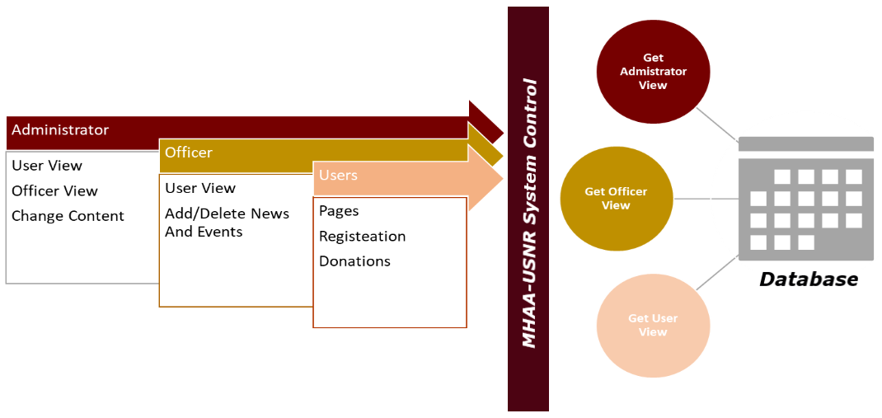

Figure 1 MHAA-USNR Design Concept

# Tools and programs

The MHAA-USNR will be hosted on Apache Web Server. The system will be using PHP as the Server-side web scripting language and MySQL as the Database Management System.

* The coding languages that will be used to implement this project are:

1. PHP
2. HTML
3. CSS
4. SQL

* The programs that will be used to implement this project are:

1. XAMPP
2. Komodo IDE

# Modules to be Implemented

For each model listed below, please refer to the Design document (MHAA-USNR-Dynamic-Website-Design-Document.doxc) section specified in the table for the **completion criteria**.

|  |  |  |  |  |  |  |  |
| --- | --- | --- | --- | --- | --- | --- | --- |
| **NO.** | **Module Name** | **Description** | **Language** | **Completion criteria** | **Progress** | **Unit Testing Result** | **Programmer** |
|  | Static Pages | * Homepage * History * Alumni News * Events * Officers * Donations * FAQs | HTML, PHP, CSS | 5  Unified Pages Look | 100% | Success | Aseel Aloweiwi |
|  | Navigation | Ability to view and access website pages | HTML, PHP, CSS | 5  Unified Pages Look | 100% | Success | Aseel Aloweiwi |
|  | Event Registration Process | Ability to register and pay for an event via the website’s Upcoming-Event information page | HTML, PHP, CSS | 10.1.2  Event Registration | 80%  (The system still needs to confirm “Event Date” not Expired and sends an email to confirm the registration process) | Success | Aseel Aloweiwi |
|  | Donation Process | Ability to donate funds to the clients specified bank account via the website Donation page. | HTML, PHP, CSS | 12  Donations | 90%  (System needs to send a confirmation email) | Success | Aseel Aloweiwi |
|  | Payment integration | Allows the user to use Visa card and Mastercard to post a payment for the association. | HTML, PHP, CSS | 10.1.2.2  Payment Information Form | 50%  (System needs to detect the card type and communicate with the related company). | Fail | Aseel Aloweiwi |
|  | PayPal integration | Allows the user to login to his/her PayPal account via the website and post a payment for the association. |  | 10.1.2.2  Payment Information Form | 0% | Fail | Aseel Aloweiwi |
|  | Login | Allows officers to gain “Officers View” and the administrator to gain “Administrator View” | HTML, PHP, CSS | 11.1  Officers Login | 100% | Success | Aseel Aloweiwi |
|  | Forget Password | Allows Officers change the password required for login | HTML, PHP, CSS | 11.2 | 50% | Fail (Email sending failed). | Aseel Aloweiwi |
|  | Forget Username | Allows Officers to retrieve their associated MHAA-USNR system username. |  | 11.3 | 0% |  | Aseel Aloweiwi |
|  | Logout | Allows officers and the administrator to logout of the system and go back to the “User View”. | HTML, PHP, CSS | 11.1  Officers Login | 100% | Success | Aseel Aloweiwi |
|  | Add News Process | Allows Officers/Admin to reflect a News record and its information on the Alumni News page | HTML, PHP, CSS | 9.2.1  Add News Record | 100% | Success | Aseel Aloweiwi |
|  | Delete News Process | Allows Officers/Admin to remove a News record and its information from the Alumni News page | HTML, PHP, CSS | 9.2.2  Delete News Records | 100% | Success | Iman Almutairi |
|  | Add Upcoming Event Process | Allows Officers/Admin to reflect an Upcoming-Event record and its information on the Events page | HTML, PHP, CSS | 10.2.1  Add Upcoming-Event | 100% | Success | Aseel Aloweiwi |
|  | Delete Upcoming-Event Process | Allows Officers/Admin to remove an Upcoming-Event record and its information from the Events page | HTML, PHP, CSS | 10.2.2  Delete Upcoming-Event Record | 100% | Success | Iman Almutairi |
|  | Add Previous-Event Process | Allows Officers/Admin to reflect a Previous -Event record and its information on the Events page | HTML, PHP, CSS | 10.4.1  Add Previous-Event | 100% | Success | Aseel Aloweiwi |
|  | Delete Previous-Event Process | Allows Officers/Admin to remove a Previous-Event record and its information from the Events page | HTML, PHP, CSS | 10.4.2  Delete Previous-Event Record | 100% | Success | Iman Almutairi |
|  | Change Homepage | Allows the administrator to change the paragraph displayed in the Homepage | HTML, PHP, CSS | 14.1  Administrator View | 100% | Success | Aseel Aloweiwi |
|  | Change History | Allows the administrator to change the paragraph displayed in the History page | HTML, PHP, CSS | 14.1  Administrator View | 100% | Success | Aseel Aloweiwi |
|  | Change Contact Us | Allows the administrator to change the Contact us information displayed in the “Bottom Section” | HTML, PHP, CSS | 14.1  Administrator View | 100% | Success | Aseel Aloweiwi |
|  | Change FAQs | Allows the administrator to change the questions and the answers displayed in the FAQs page. | HTML, PHP, CSS | 14.1  Administrator View | 100% | Success | Aseel Aloweiwi |
|  | Email Notifications | System issues email notification on trigger |  | 13 | 0% | Fail | Aseel Aloweiwi |

# MHAA-USNR System Code

For the system code (PHP files) refer to the package and extract the “Alumni” file.

# Release Notes

* Refer to section (7. Modules to be implemented), all modules with status “Fail” are to be deployed in version 2.0.
* MHAA-USNR website is currently operating with the listed modules in section (7. Modules to be implemented) as status “Success” on Google Chrome browser.
* The following table contains any necessary data for operating the system.

|  |  |  |
| --- | --- | --- |
| **Username** | **Password** | **Function** |
| Administrator | AliceInWonderLand | A login with this combination of username and password will enable administrator-view privileges. |
| mhaa-aseel.al1 | JordanAmman90 | A login with this combination of username and password will enable administrator-view privileges. |
| mhaa-mira.bo2 | EgyptCairo97 | A login with this combination of username and password will enable administrator-view privileges. |
| mhaa-shada.kh3 | shadaKhanneh123 | A login with this combination of username and password will enable administrator-view privileges. |
| mhaa-iman.al4 | imanAlmtairi1234 | A login with this combination of username and password will enable administrator-view privileges. |
| Mhaa-amal.al5 | amalAlamri1234 | A login with this combination of username and password will enable administrator-view privileges. |